|  |  |  |  |  |  |  |
| --- | --- | --- | --- | --- | --- | --- |
| **Topics: Week 3- 4** | | **Total Marks: 25** | | **Obtained Marks:** | | |
| **Registration No. :** L1_______BSCS____________ | | | **Date:** | | | |
| **Section: A20** | | | **Name:** | | | |
| **Questions Attempted (Y/N)**  Question 1: | | | | | | |
| **CLO #** | **CLO Statement** | | | | **Taxonomy Level** | **PLO** |
| **2** | **Solve basic problems using fundamental concepts of programming language (C++).** | | | | **C3 (Apply)** | **2** |
| **Submission:**  **Soft Copy Deadline: 28-11-2024 till 11:59 PM via Portal**  **Hard Copy Deadline: 29-11-2024**  **Late Submission Policy:**   * 10% Deduction /24 Hours.   **Submission Marks:**   * 5 marks are for submission.   **Instructions: (5 marks will be deducted for not following the instructions)**   * This is an individual assignment. Viva can be conducted OR a Quiz will be taken on the basis of assignment in the next week. * Attempt all questions in sequence. Attach this title page as a front page of assignment. * Assignment should be handwritten/printed on A4 sized page. **(No pages from register please.)** * Submit Hard copy in class and scanned copy of solved assignment on the portal **(Both copies should be submitted before deadline)** | | | | | | |



**UNIVERSITY OF CENTRAL PUNJAB**

**FALL 2020**

FALL 2024

**Course Title: Introduction to Computing**

**Course Code: CP103**

**Assignment No. 2**

**Question: 1 (20 Marks)**

A scenario is given to you. **Apply** the fundamental concepts of programming language C++ and solve the scenario.

**Scenario:**

A school cafeteria wants to automate its food ordering system to improve efficiency and ensure better service for students.

**Problem Description:**

Solve the following tasks in your program:

1. **Check Account Status:**  
   The system should verify if the student has a registered cafeteria account:
   * **Yes:** Proceed to the menu selection.
   * **No:** Display a message: "Please register for a cafeteria account."
2. **Select Meal Type:**  
   Once the account is verified, prompt the student to select a meal type:
   * 1: Breakfast
   * 2: Lunch
   * 3: Snacks
3. **Select Food Item:**  
   After choosing the meal type, display a list of available food items in that category and allow the student to choose one.  
   Example:
   * **Breakfast:**  
     1: Pancakes  
     2: Omelette
   * **Lunch:**  
     1: Pasta  
     2: Chicken Sandwich
   * **Snacks:**  
     1: Chips  
     2: Fruit Cup
4. **Order Confirmation:**  
   Display an order confirmation with the following details:
   * Student's Name
   * Meal Type
   * Selected Food Item

Solution:  
 Program:-

#include<iostream>

using namespace std;

int main()

{

string st;

char acc;

cout << "Enter Student name: " << endl;

cin >> st;

cout << "Do you have a account? (y/n)" << endl;

cin >> acc;

if (acc == 'n'&& acc!='y')

{

cout << "Please register for a cafe account" << endl;

return 0;

}

int m_type;

cout << "Please select meal type.(e.g 1,2,3)" << endl;

cout << "1: Breakfast" << endl;

cout << "2: Lunch" << endl;

cout << "3: Snacks" << endl;

cin >> m_type;

if (m_type == 1)

{

cout << "Please select Breakfast" << endl;

cout << "1: Omelette" << endl;

cout << "2: pancakes" << endl;

cin >> m_type;

}

else if (m_type == 2)

{

cout << "Please select Lunch" << endl;

cout << "1: Pasta" << endl;

cout << "2: Chicken sandwich" << endl;

cin >> m_type;

}

else if (m_type == 3)

{

cout << "Please select Sancks" << endl;

cout << "1: Chips" << endl;

cout << "2: FruitCup" << endl;

cin >> m_type;

}

else

cout << "Please Select valid Choice" << endl;

cout << "Order confirmation" << endl;

cout << "Student name" << st << endl;

cout << "m_type: " << (m_type == 1 ? "Breakfast" : m_type == 2 ? "Lunch" : "Snacks:") << endl;

cout << "Item :" << m_type << endl;

}

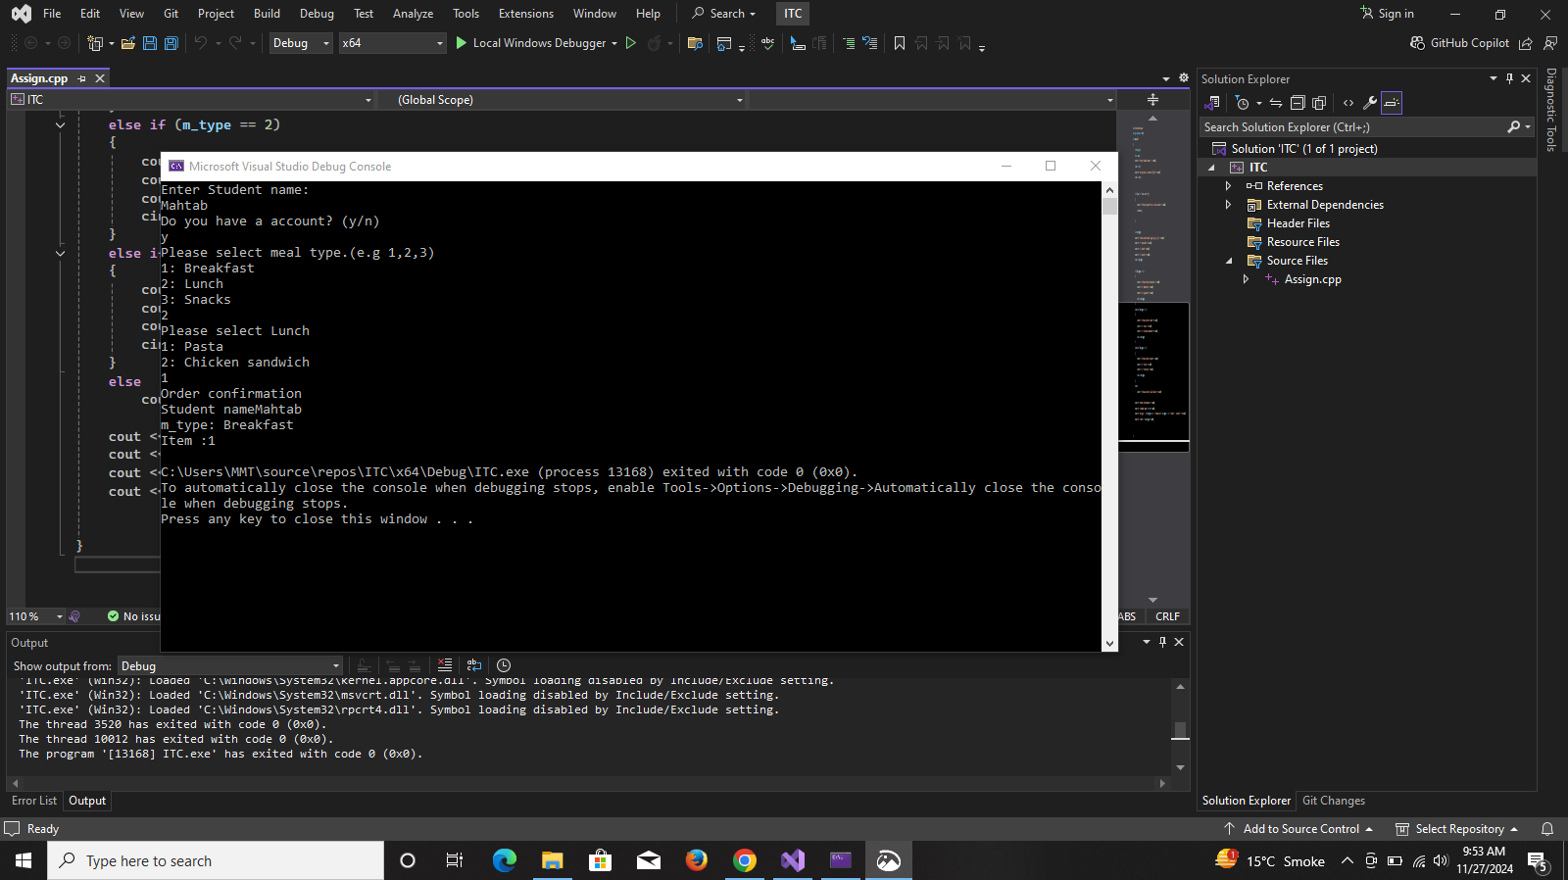s